SOS-TORTURE / BURUNDI REPORT No. 145 ISSUED ON 22 SEPTEMBER, 2018
This SOS-Torture/Burundi report covers the period between 15 to 22 September 2018 concerning cases of violations and human rights violations in Burundi.
At least three (3) persons were murdered during the period. Among the victims include a couple of Kayanza whose husband was beheaded by his executioners. The body of a young man was also found packed in a bag in the north of Bujumbura town, no identification to date.
The report also notes cases of kidnapping and enforced disappearances. At least four (4) cases are listed including two active members of the security forces. An activist from the opposition MSD party has also been missing since his abduction in Ngozi last month.
Several cases of arbitrary arrests and one case of torture committed by members of the ruling party's imbonerakure militiamen in Cibitoke.

- Violations of the right to life and to physical integrity

- On September 16, 2018 unidentified individuals murdered a man whose body was found in a gutter in quarter 9, Ngagara zone, Ntahangwa commune (north of Bujumbura town). Witnesses report that the victim was packed into a bag he was executed elsewhere and his body thrown into this gutter by his executioners.

SOS-Torture/Burundi notes that the police have not identified the victim so far nor determined the circumstances of his assassination.
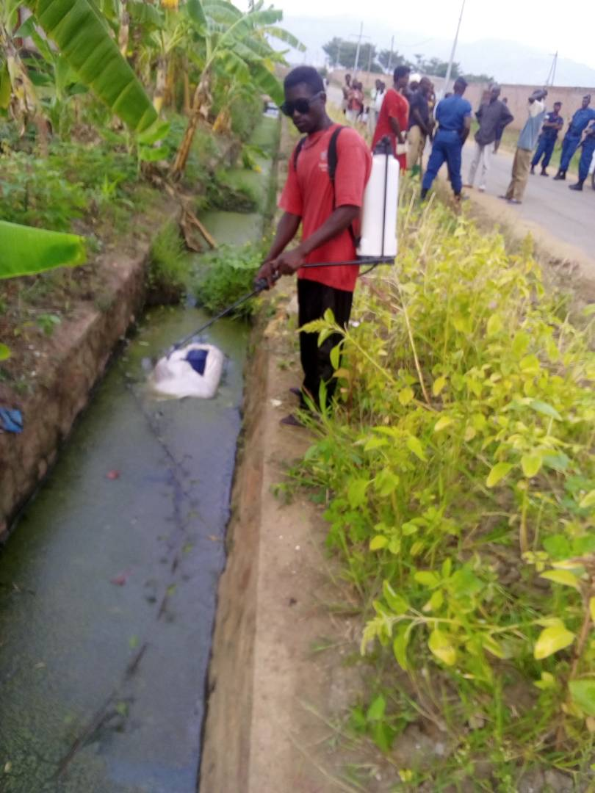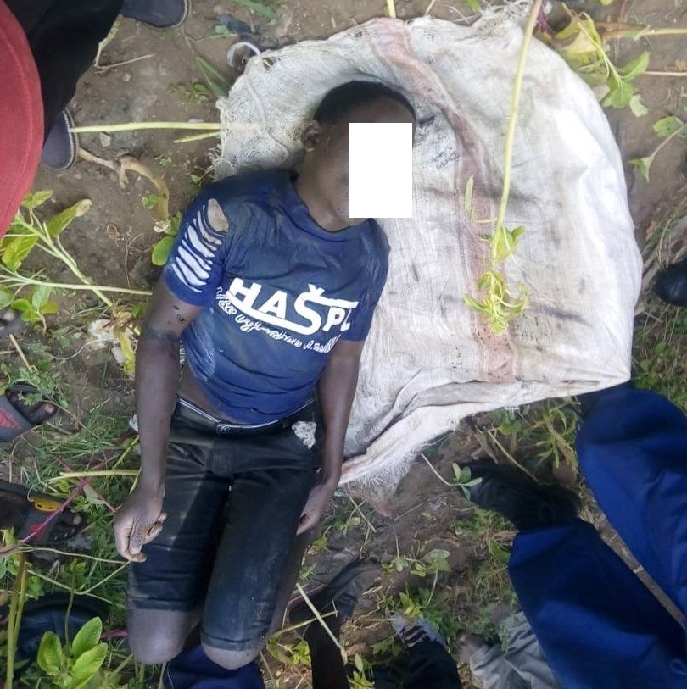
The body of the victim was packed in a bag and deposited in a gutter

- Unidentified individuals attacked by grenade and attempted to murder Daniel Mubaji and his wife on Nyabigabiro Hill, Gisuru Commune, Ruyigi Province (East) in the evening of 16th September, 2018. Witnesses report that the perpetrators attacked the door of the couple's residence and threw a grenade through the mainr bedroom. Both victims were seriously injured and evacuated to a hospital.

Sos-Torture/Burundi notes that the police announced the arrest of a suspect, Salvator Nikozubaka, who threatened the couple by accusing it of witchcraft.

- Individuals identified as agents of the National Intelligence Service (SNR) kidnapped Jean Claude Habiyakare nicknamed Kibaju in the city of Bujumbura on September 17, 2018 in the evening. Relatives report that the victim is an active soldier of the Burundian army assigned to the office of the General Staff. He was abducted while returning to Ngagara camp (north of Bujumbura town) where he resides.

Sos-Torture/Burundi notes an enforced disappearance, with a risk of execution of the victim. Since his disappearance, the relatives have no news and report that Mr. Habiyakare is not in any official cell in the city of Bujumbura.
Jean Claude Habiyakare nicknamed Kibaju, a soldier in activity victim of enforced disappearance.

- On September 18, 2018 in the evening unidentified individuals murdered Daniel Ngendakumana nicknamed Kayongwe and his wife on Buyumpu Hill, Rugazi Zone, Kabarore Commune, Kayanza Province (north-west of the country). Witnesses report that the perpetrators used rifles and beheaded the husband whose head was not found.

Sos-Torture/Burundi notes that the police have not identified any suspects to date. Mr. Ngendakumana, whose body was beheaded, was the local leader of CNND-FDD party's imbonerakure militiamen. The assassination of this couple seems linked to political motives.

- Individuals abducted Theophile Nibitanga in the Cibitoke province (north-west of the country) on 18 September 2018, where he was assigned as Burundian Police Brigadier at Ruhwa border crossing. Relatives report that he had recently been assigned to this position, from Mabanda commune (Makamba province) where he previously worked.

Sos-Torture/Burundi notes an enforced disappearance of the victim, with the risk of execution. Relatives report that Mr. Nibitanga is a former member of the Burundian Armed Forces before the reform of the defense and security forces, who joined the national police. The relatives of the victim suspect agents of the national intelligence service to be the perpetrators of the enforced disappearance of Mr. Nibitanga. They received calls explaining that the Non Commissioned Officer is being held in the cell of judicial police, but relatives report that this was not the case.

SOS-Torture/Burundi also notes that several active members of the security forces have been victims of extrajudicial executions, enforced disappearances, torture and arbitrary detention since the beginning of the crisis in April 2015.
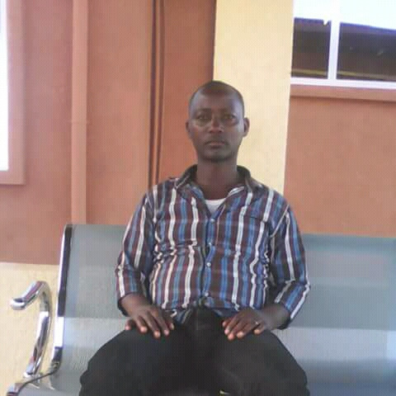
Theophile Nibitanga, Non-Commissioned Officer abducted by individuals suspected of being agents of the SNR

- Individuals kidnapped Jean Claude Nsabimana in Rohero zone, Mukaza commune (center of Bujumbura city) not far from Burundian presidential offices on September 20, 2018. Witnesses report that his captors were three in number and he was arrested. cut off the priority while driving, forcing him to stop before removing him.

Sos-Torture/Burundi has learned from relatives that Mr. Nsabimana is a customs agent and real estate agent. Relatives suspect National Intelligence Service agents to be his captors. Mr. Nsabimana is said to be the victim of a weapon found in a house that he looks after as a real estate agent, according to his relatives. He had previously been detained briefly in the national intelligence service a few weeks ago for false accusations of participating in an illegal political meeting.
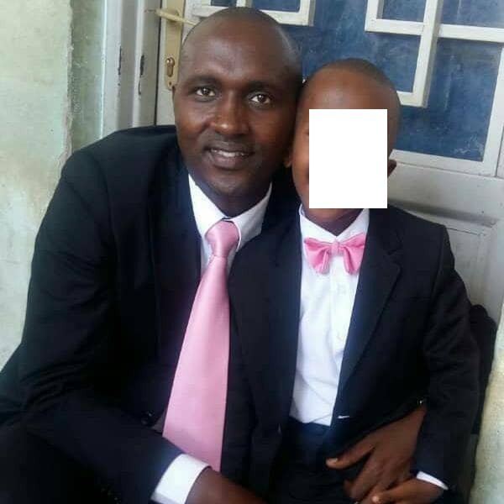
Jean Claude Nsabimana kidnapped by individuals suspected to be SNR agents

- Unidentified individuals also abducted Marius Ndayikengurutse, whose relatives report the disappearance since 21 August 2018 in the evening. He was allegedly abducted by agents of the National Intelligence Service in the northern town of Ngozi. Relatives report that he is a teacher at Sainte Dorothée High School in Rukago, Gahombo commune, Kayanza province (north-west of the country).

Sos-Torture/Burundi also learned from relatives that Mr. Ndayikengurutse is an active militant of MSD opposition party in his native commune Tangara (Ngozi). His relatives have not heard from him since his enforced disappearance.
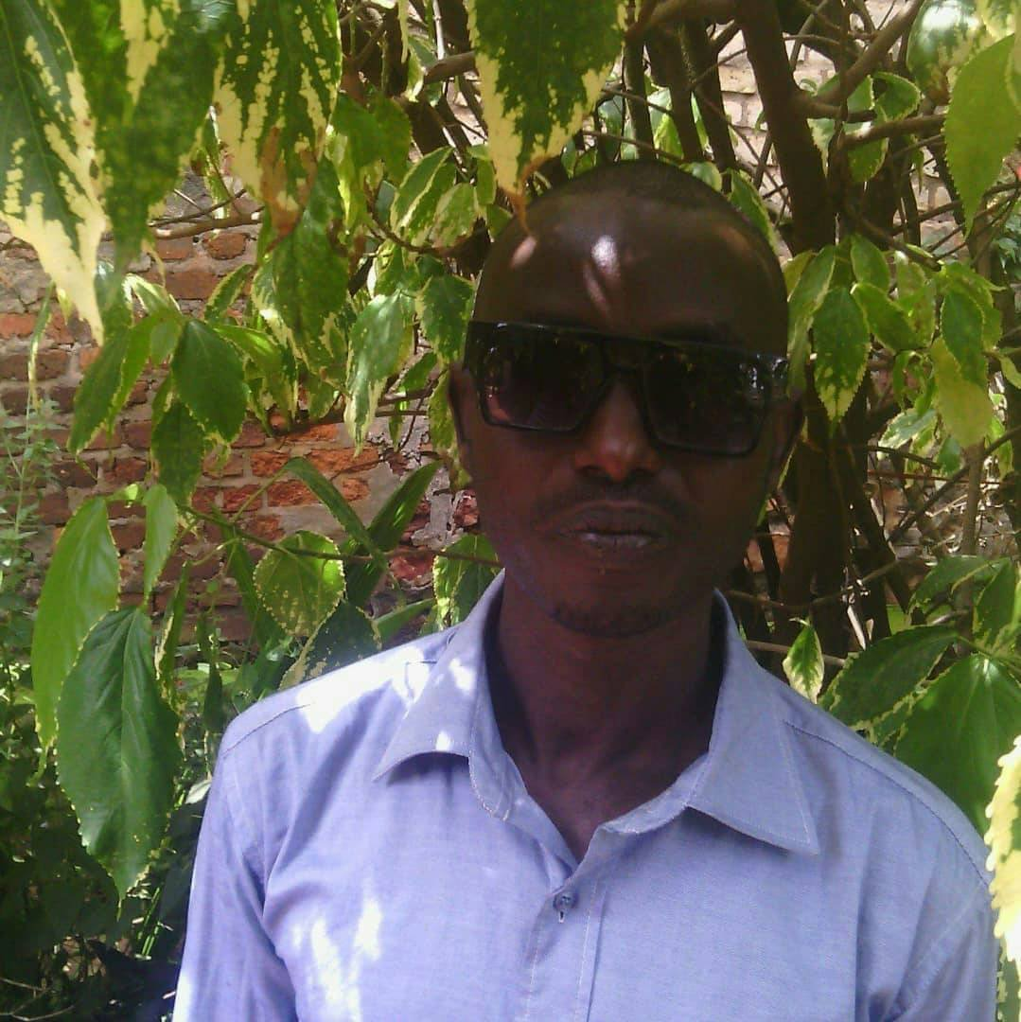
Marius Ndayikengurutse, opposition member kidnapped in Ngozi

- Violations of the right to liberty and physical security

- Young members of imbonerakure militiamen illegally arrested Lazare Manirambona (65 years) on Jimbi Hill, Kibago Commune, Makamba Province (South) on 13 September in the evening. Relatives report that the man was arrested in the house of a widow.

Sos-Torture/Burundi notes that Mr. Manirambona is being held in Kibago commune police cell without any reason. The police complied with an unlawful and arbitrary arrest.

- Members of Imbonerakure militiamen violently tortured Elias Yamuremye on Rugajo Hill, Mugina commune, Cibitoke province, north-west of the country, on September 15, 2018. Relatives report that the victim is the vice-representative of the opposition party FNL faithful to MP Agathon Rwasa in Mugina commune. He was called for an appointment by the communal executive secretary of the ruling party CNDD-FDD, who was waiting for him with militiamen to beat him. The local leader of the ruling party blames the victim for refusing to join CNDD-FDD party.

SOS-Torture/Burundi notes the seriousness of the beatings inflicted by militiamen affiliated with the ruling party, as well as the impunity enjoyed by the perpetrators of the torture to date. The victim, however, identified his attackers: Alexis Nibizi (communal secretary of the ruling party), as well as members imbonerakure militiamen Augustin Nkurikiye, Nestor Nzokirantevye and Paul, none of them were arrested by the police. Mr. Yamuremye had to be evacuated to a health center for intensive care.

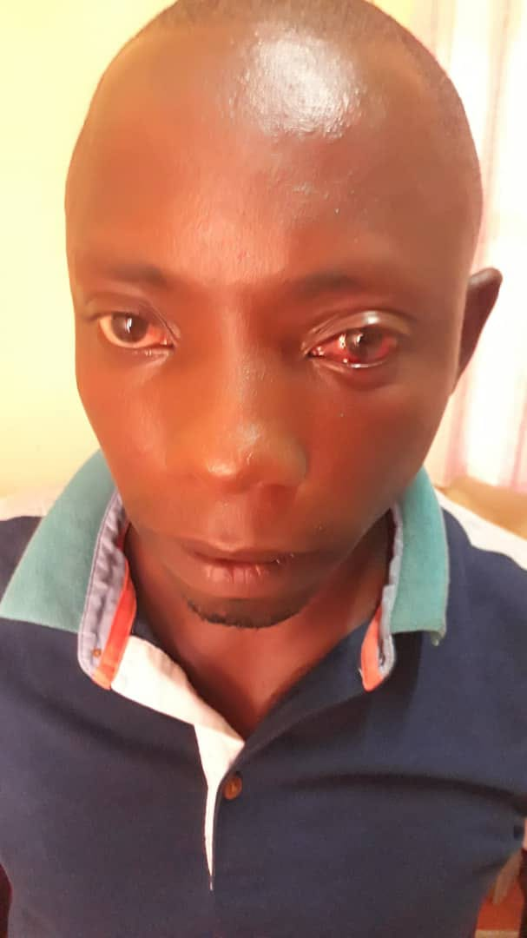
Mr. Elias Yamuremye whose face still bears traces of blows

- The police chief of Nyanza-Lac commune arrested Dieudonné Kigingi, Lambert and Samuel Ndayishimiye in the center of Nyanza-Lac commune, Makamba province (south of the country) on September 19, 2018. Relatives report that the first two are motorcycle taxi drivers detained for asking for the statement of accounts of the motorcycle association for which they give contributions. The third person arrested is the victim of having sensitized other motocyclists to support their detained comrades.

Sos-Torture/Burundi notes arbitrary arrests by police agents. The police chief of Nyanza-Lac acted without warrant and without motive to arrest these individuals.

- Police agents arrested several people (men and women) in a house on Rubira hill, Musenyi zone, Mpanda commune, Bubanza province (western part of the country) on September 19, 2018. Witnesses reported that all those arrested were activists of the FNL opposition party faithful Agathon Rwasa.

Sos-Torture/Burundi notes that the police accuse these opponents of having organized an illegal meeting, but did not communicate the identities of those arrested. Witnesses also report that a local administrative officer, Murengeza Sector Chief, was leading the arrest operation.
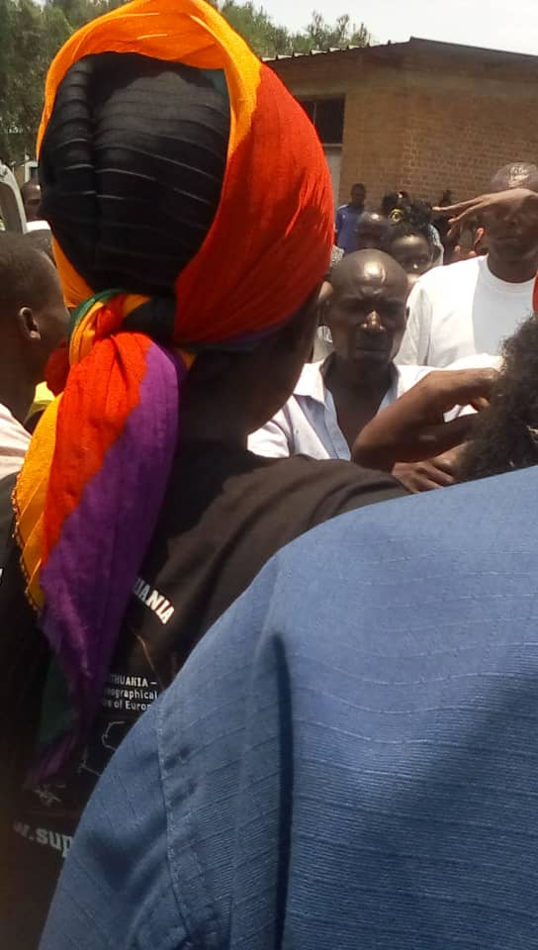
Partial view of people arrested by the police (sample photo).

SOS-Torture/Burundi was initiated with the aim of informing national and international opinion about serious human rights violations under way in Burundi through monitoring reports, particularly on torture, arbitrary arrests, enforced disappearances, sexual violence and summary executions.
This initiative to inform about the realities of the country followed a slaughter of a hundred persons killed during the day of 11 and 12December, 2015 done the by police and military on the pretext of pursuing rebels who came to attack military camps on the outskirts of the capital city
The affected zones are said to be contesting the third term of President Nkurunziza namely Musaga, Mutakura, Cibitoke, Nyakabiga, Jabe, the last two being located in the center of Bujumbura City Council.

