SOS-TORTURE / BURUNDI REPORT No. 149 PUBLISHED ON OCTOBER 20, 2018
This SOS-Torture/Burundi report covers the period between 13 and 20 October 2018 concerning cases of human rights violations in Burundi.
At least three (3) persons were murdered in different localities during the period. Among the victims include a man whose bloody body was found in Mubarazi River but was not identified. One (1) case of enforced disappearance is noted in this report, that of a non-commissioned officer of the Burundian army. He disappeared during an appointment with a military police agent.
The report also notes victims of arbitrary abusive arrests and detentions : at least six (6) listed cases, including an activist of UPRONA opposition party as well as magistrates detained abusively despite a court order ordering their release.

- Violations of the right to life and to physical integrity

- Unidentified individuals abducted Sergeant-Major Lucien Ntakarutimana (nicknamed Mututere) in quarter III, Ngagara Zone, Ntahangwa Commune (north of Bujumbura City) on October 7, 2018. This is a serving military member to the Army Staff. Relatives report that he has answered an appointment after the call of Pascal Hakizimana (nicknamed Nyangoma), a member of the military police, and has not returned since.

Sos-Torture/Burundi notes an enforced disappearance with a risk of execution of the victim. No investigation was opened to find the soldier, which confirms an act committed by a member or members of the security services against another serving soldier. Sergeant-Major Ntakarutimana is also an FNL veteran, integrated into the army after ceasefire agreements.
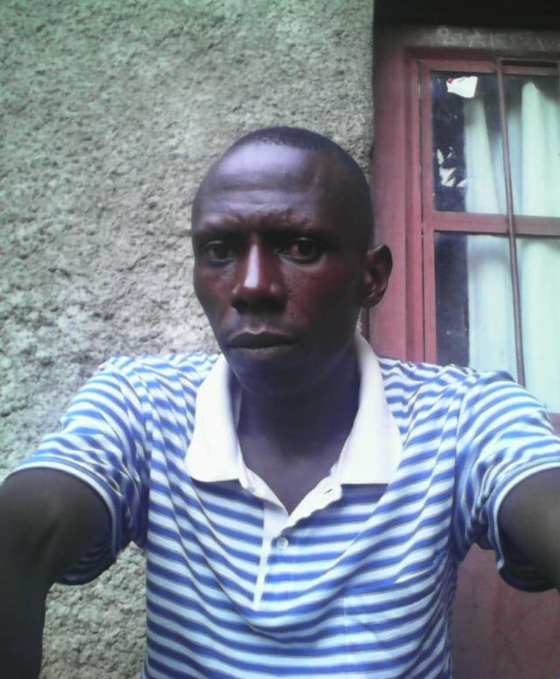
Sergeant Ntakarutimana, disappeared since his last appointment with a military police officer.

- Unidentified individuals murdered Salvator Ruriryanino (50) on Butavuka Hill, Muzinda zone, Rugazi commune, Bubanza province (western part of the country) on 12 October 2018 in the evening. Witnesses report that the victim was cut with machetes several times.

Sos-Torture/Burundi notes that Bubanza police have announced the arrest of two (2) suspects.

- Unidentified individuals seriously injured Bukuru (65 years) on Nyaburondwe hill, Butaganzwa commune, Kayanza province (north-west of the country), on October 12, 2018. Witnesses report that he was intercepted by a group of individuals who beated him in the head, neck, back and arms, wounding him.

Sos-Torture/Burundi notes the violence of the attack which caused the hospitalization of the victim. Relatives report that Mr. Bukuru was accused by his attackers of practicing witchcraft. The police have not identified any suspects of the attack so far.
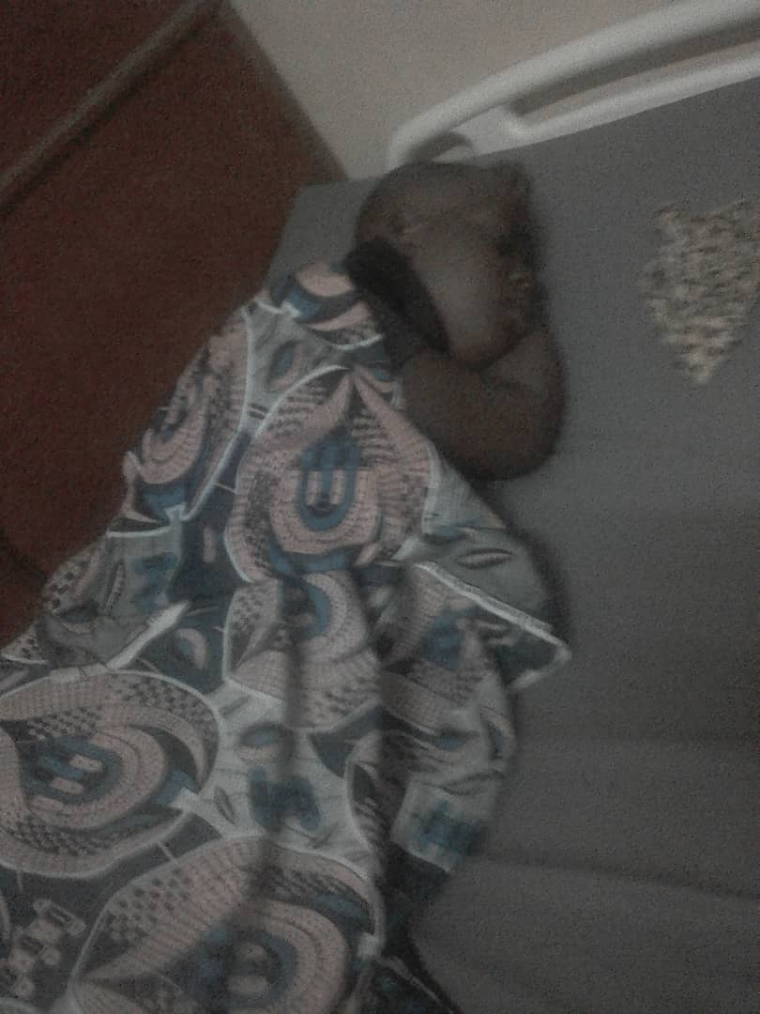
Mr.Bukuru hospitalized following a violent assault

- Unidentified individuals murdered a man whose body was discovered floating in the Mubarazi River between Bugesera hill, Mbuye commune and Murambi hill, Kiganda commune, Muramvya province (center of the country) on October 16, 2018. Witnesses reported that the victim had traces of blood in his face.

Sos-Torture/Burundi notes that the police have not identified the victim nor the suspects to date. Victims of executions have been found in rivers since the beginning of the crisis, most of which have not been identified so far.

- Unidentified individuals murdered a man in Buhinyuza quarter, Kinama zone, Ntahangwa commune (north of Bujumbura town) on October 17, 2018.

SOS-Torture/Burundi notes that the police have not identified any suspects to date.
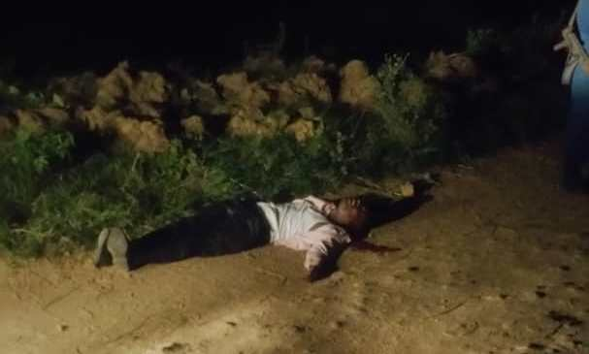
The murdered victim in the Kinama Zone

- Violations of the right to liberty and physical security

- Police agents arrested Samson Gahungu 54 years in Gihanga commune, Bubanza province (western part of the country) on 13 October 2018. He is an activist of UPRONA opposition party and a member of the opposition coalition Amizero y'Abarundi. Witnesses report that Mr. Gahungu was arrested at the end of a commemoration mass of the hero of independence in Burundi. Relatives report that he is accused of collaborating with a member of the Amizero y'Abarundi coalition to denounce human rights violations committed in Gihanga.

Sos-Torture/Burundi notes an arbitrary arrest against a political opponent. The arrest also appears to be aimed at silencing denunciations of crimes committed in Burundi, whether initiated by political opponents or by human rights defenders. The police did not communicate the reasons for this arrest.

- The Prosecutor General's Office at Bururi Appeal Court level illegally detains Spinat Nsabiyaremye, Emmanuel Niyongabo and Silas Nibasumba in Bururi Prison (south of the country). They are three (3) judges of Residence court of Nyanza-lac (province Makamba) acquitted by the court of Appeal of Bururi on October 9, 2018 on accusations of forgery in public writing for which they were persecuted since July 2018.

SOS-Torture/Burundi notes a violation of the rights of these detainees, who must benefit from the release. Relatives report that the prosecutor's office of Bururi Court
Appeal refused to implement the judgment of the Court of Appeal. These three persons are victims of illegal and abusive detention.

- The leader of CNDD-FDD ruling party in Giheta commune arrested Benoît Bimenyimana on Gisuru hill, Giheta commune, Gitega province (center of the country) on October 13, 2018. Relatives report that the leader of the ruling party was accompanied by Giheta communal administrator and Gitega province sanitary doctor.They accuse Mr. Bimenyimana of selling expired drugs in his pharmacy.

Sos-Torture/Burundi also learned that Mr. Bimenyimana is a member of the opposition FNL opposition party of the deputy Agathon Rwasa.

SOS-Torture/Burundi also notes an illegal arrest and the complicity of Giheta's police agents who incarcerated the victim without a warrant and in blatant violation of the procedure, especially since the arrest was made by people who hasn't the quality and required prerogatives.

- Members of Imbonerakure militiamen violently assaulted Bazamenyo Method on Rushwahunga Hill, Bweru Commune, Ruyigi Province (East of the Country) on October 14, 2018. Eyewitnesses report that the victim stumbled upon one of these militiaman named Fitius Nsengiyumva and he started beating him. The victim managed to escape, but was caught near his home by militiamen Fitius Nsengiyumva, Jean Kigenge and Thaddée Ntiruhava. Relatives reported that they beated the victim again, and severely wounded him with a knife.

Sos-Torture/Burundi notes the violence of the attack, whose victim was evacuated to two hospitals for treatment. Bweru police announced the arrest of only one suspect among the identified attackers, Jean Kigenge. Witnesses report that the other two imbonerakure militiamen enjoy the protection of their leader in Bweru commune.

- Police agents arrested Bwarikindi Terence in Ngagara zone, Ntahangwa commune Bujumbura city hall on October 19, 2018. This one is an employee of the Ministry of Public Health and AIDS. According to witnesses, these police agents were accompanied by agents of national intelligence service. Mr. Bwarikindi was searched at his home before being taken to and held in Bujumbura National Intelligence Service. Relatives report that his private documents, his computer and his car were seized.

SOS-Torture/Burundi notes that the police gave no explanation for arrest without warrant.

SOS-Torture/Burundi was initiated with the aim of informing national and international opinion about serious human rights violations under way in Burundi through monitoring reports, particularly on torture, arbitrary arrests, enforced disappearances, sexual violence and summary executions.
This initiative to inform about the realities of the country followed the slaughter of a hundred people killed during the day of December 11 and 12, 2015 by the police and the military on pretext of pursuing rebels who came to attack military camps on the outskirts of the capital city.
The affected zones are said to be contesting Nkurunziza President's third term namely Musaga, Mutakura, Cibitoke, Nyakabiga, Jabe, the last two being located in the center of the Bujumbura City Hall.

