SOS-TORTURE/BURUNDI REPORT No. 156 PUBLISHED ON DECEMBER 8, 2018
This report from Sos-Torture/Burundi covers the period between 1 and 8 December 2018 concerning cases of human rights violations in Burundi.

At least two (2) persons were murdered during the period and in different localities. The victims are a member of the political opposition of Bubanza as well as a family's mother shot in the city of Bujumbura.

A reported raped case: the victim is a six years girl and her abuser has been arrested.
The report also mentions cases of arbitrary arrests and an attack perpetrated by members of the imbonerakure militiamen and militiamen and administrative also continue to collect money and threating people for the 2020 elections. These collections are increasing in schools.

- Violations of the right to life and to physical integrity

- Non-dentified individuals shot and killed Nahayo on Gitanga Hill, Bubanza commune and province (west of the country) on November 30, 2018 in the evening. Relatives report that the victim is an active member of the opposition Amizero y'Abarundi coalition.

Sos-Torture/Burundi notes that Bubanza police have not yet identified any suspects. Fear that this assassination is related to the political affiliation of the victim.

- A police agents shot and killed Louise Hagabimana 36 years at her home in Kajiji quarter, Kanyosha zone, Muha commune (south of Bujumbura city) on 4 December 2018. The victim is the wife of the killing officer, Major Prime Nduwimana. Witnesses report that the couple quarreled, and the husband became violent by slapping his wife and then shooting him repeatedly with his service weapon. The couple's baby that was carried in the back by the wife was seriously injured; hewas only eight (8) months old.

Sos-Torture/Burundi notes that the police officer was arrested and detained, and was brought before the court following flagrante judgment on 7 December 2018. The court sentenced Major Nduwimana to life imprisonment and a fine of fifty (50) million Burundian francs as damages to the father of the victim who is in charge of children custody. The shot dead victim had six (6) children with this murderer.
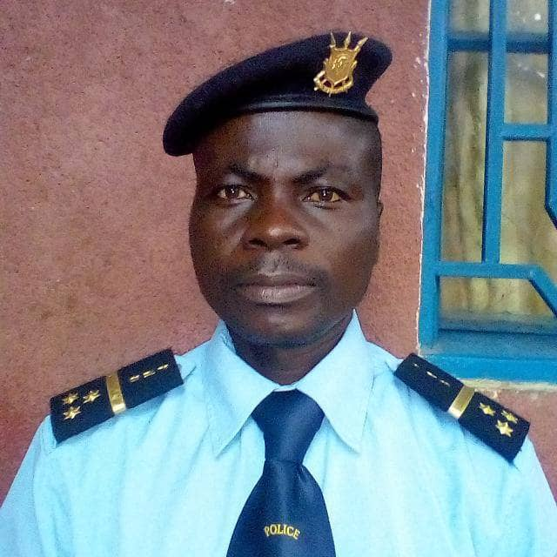
Major Prime Nduwimana shot his wife with his service weapone

- A soldier raped a six years girl on Gahoma Hill, Butahana Zone, Mabayi Commune, Cibitoke Province (north-west of the country) on December 5, 2018. Witnesses report that he was caught read handed during the aggression.

Sos-Torture/Burundi notes that the perpetrator of the rape was arrested and detained. The victim was hospitalized following this violent aggression.

- Violations of the right to liberty and physical security

- Police agents arrested Saleh Gitabu in the center of Bubanza commune and province (west of the country) on December 1, 2018. Witnesses report that he is accused of rebellion, according to a warrant from Bubanza prosecutor. The day before his arrest, he was quoted by participants to Bubanza governor's meeting as funding rebel groups. Relatives report, however, that Mr. Gitabu is a victim of not having contributed to CNDD-FDD ruling party of which he is a member since the beginning of 2015 crisis.

Sos-Torture/Burundi notes a risk of arbitrary arrest of Mr. Gitabu. He had fled to Rwanda at the beginning of the crisis and come back this year. Several people who have stayed in Rwanda have been the victims of arbitrary arrests, sometimes enforced disappeared due to bad relations between Burundi and Rwanda. The Burundian authorities accuse Rwanda of wanting to destabilize Burundi.

- Members of Imbonerakure militiamen assaulted Jean Marie on Kibago hill and commune, Makamba province (southern part of the country), on 2 December 2018. Witnesses report that the young student was also threatened with reprisals including ethnic revenge: Militiamen told him that "Tutsis have to pay what they did in 1972," referring to the massacres of Hutus at that time.

Sos-Torture/Burundi also notes the complicity of local administrative and police authorities. The victim lodged a complaint against his attackers whom he identified: militiamen Anicet Ndayongeje and Jean Bosco Irakoze. But no follow-up was given to this complaint.

- Forced collections in schools are multiplying

SOS-Torture/Burundi learned from several witnesses that pupils of Kirundo School of Public Works (north of the country) are forced by the director of the school to contribute an amount of 2000 francs/each for 2020 elections. This director, Marc Nduwamahoro, is an active member of imbonerakure militiamen of the ruling party CNDD-FDD. He threatened to retaliate students who would not hand over their contributions.

Sos-Torture/Burundi notes the forced character and politicization imposed in school activities. Parents of pupils report, however, that they have already contributed as a household within the local administration for the same activity. Witnesses also report that the director of this school has threatened students who do not join the party CNDD-FDD.

More and more school leaders are demanding additional forcibly contributions to students before the end of the current term.

On the other side, in the province of Makamba (South of the country), contributions are binding. Obviously, the Governor of Makamba Province, Gad Niyukuri is ready for anything. Threats of dismissal continue to be made against local elected representatives and school principals. The illustrative case is the dismissal of SAGIRIJE, Kanzenge hill chief, Makamba Commune, Makamba Province, for failing to collect sufficient contributions for the 2020 elections. Others were warned and the main victims are the students who are now deprived of their evaluation because of the lack of financial means to contribute to elections.

SOS-Torture/Burundi was initiated with the aim of informing national and international opinion about serious violations of human rights under way in Burundi through monitoring reports, made particularly with torture, arbitrary arrests, enforced disappearances, sexual violence and summary executions.
This initiative to inform about the realities of the country followed the carnage of a hundred people killed during the day of 11 and 12 December 2015 by police and military on the pretext of pursuing rebels who came to attack military camps on the outskirts of the capital city.
The affected zones are said to be contesting the third term of President Nkurunziza namely Musaga, Mutakura, Cibitoke, Nyakabiga, Jabe, the last two being located in the center of Bujumbura City Council.

