SOS-TORTURE/BURUNDI REPORT No. 182 PUBLISHED ON JUNE 8, 2019
This report of SOS-Torture/Burundi covers the period between 1 and 8 June 2019 concerning cases of violations and abuses of human rights in Burundi.
At least two (2) persons were murdered during the period: victims were not identified. Two others survived an attack.
The report also mentions four (4) arbitrary arrests. Among the victims, members of the CNL opposition party. Seven (7) members of this party have been seriously injured by militiamen Imbonerakure in Mubimbi Commune.

- Violations of the right to life and physical integrity

- Unidentified individuals have murdered two (2) men whose bodies were found on Bambo hill, Ngoma zone, Murwi Commune, Cibitoke province (north-west of the country on) June 4, 2019 in the evening. Witnesses report that the victims' bodies were badly decomposed and attached to a tree.

SOS-Torture/Burundi noted that the local residents, the administration and the police have not identified the victims. Murwi communal administrator however ordered the burial without allowing further investigations that would have helped to identify the two men as potential suspects of their extrajudicial execution.

- Unidentified individuals attacked and injured by machete Venuste Nkurunziza (40 years) and Juvenile Butoyi (30 years) on Bugera hill, Ndava Commune, Mwaro province (central part of the country) on June 4, 2019 in the evening. Relatives reported that the victims were evacuated to a hospital for treatment.

SOS-Torture/Burundi notes that Ndava police announced the arrest of a suspect.

- Violations of the right to liberty and physical security

- Police agents arrested Peter Barakikana in Mvugo zone, Nyanza Lac Commune, Makamba province (south of the country) on May 29, 2019. Relatives report that he is a victim of preaches he delivered during his preach in Emmanuel church to which he is one of the faithful. These words are related to prophecies about Burundi.

SOS-Torture/Burundi noted arbitrary arrest and violation of religious freedoms of the victim by an administrative who has not prerogatives to order detention in lieu of the judicial organs. Witnesses report that the governor of Makamba Gad Niyukuri ordered the transfer of Mr. Barakikana to Murembwe prison (Rumonge province).

- Police agents arrested Rémégie Uwizeyimana and two other men in Busoni commune, Kirundo province (north of the country) on June 2, 2019. Relatives report that Mr. Uwizeyimana is the head of CNL opposition party (National Congress for the freedom) for Busoni Commune and his two companions are activists of the same party. They are accused of holding an unauthorized meeting.

SOS-Torture/Burundi noted a continued arbitrary arrests which target militants of CNL party. The arrests, persecution and intimidation have increased since the approval of the party in February 2019.

- Members of Imbonerakure militiamen attacked and seriously injured Aster Hakizimana and his wife Beatrice Kamariza, John Paul Ndayishimiye, Richard Ndereyimana, Nestor Bamporubusa and Christophe Hakizimana on Muhororo hill Mubimbi Commune, Bujumbura province on June 2, 2019 in the evening. Relatives reported that the victims were activists of the opposition CNL. Militiamen of the ruling party CNDD-FDD used machetes, clubs and knives to attack opposition members to their respective homes.

SOS-Torture/Burundi notes violent attacks against members of the opposition, particularly CNL party. The perpetrators of these attacks enjoy complete impunity since they belong to the ruling party. The police did not arrest any of the perpetrators yet known and identified by the victims.
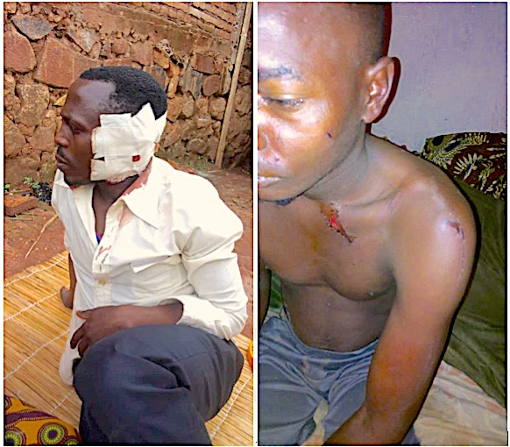
Two of the victims attacked and injured by militiamen Imbonerakure

SOS-Torture/Burundi was initiated with the aim to inform national and international opinion on serious violations of human rights ongoing in Burundi through monitoring reports including torture, arbitrary arrest, enforced disappearances, sexual violence and summary executions.
This initiative to inform about the realities of the country follows the slaughter of hundreds of people killed during the day of December 11 and 12, 2015 by police and military under the pretext of pursuing rebels who came to attack military camps located on the outskirts of the Capital City.
The affected Zones are said to be protesters of President Nkurunziza’s third term namely Musaga Mutakura, Cibitoke Nyakabiga, Jabe, the last two being located in the center of Bujumbura.

