SOS -TORTURE/BURUNDI REPORT NO. 166 PUBLISHED ON 16 FEBRUARY 2019

This report by SOS-Torture/Burundi covers the period from 9 to 16 February 2019 concerning cases of human rights violations and abuses in Burundi.

At least three (3) people were murdered during the period and in different localities. Among the victims, a decapitated man whose head is the only part discovered. Another man who was murdered and whose lifeless body was found in Cibitoke has not been identified.

The report refers to the flagrant seizure of several firearms at the homes of influential members of the imbonerakure militia in Kirundo. Despite this seizure, the owners of these weapons were released after a few days of detention and no prosecution was initiated.

1. Violations of the right to life and physical integrity

- Unidentified individuals murdered Charles Ndayisaba on Muyange Hill, Nyarusange commune, Gitega province (central part of the country) on the evening of 8 February 2019. The victim was attacked at his workplace: an agency of the Lumitel telecommunications company for which Mr. Ndayisaba was a sentinel.

Sos-Torture / Burundi noted that the Nyarusange police have not identified any suspects to date.

- Unidentified individuals murdered and beheaded a man whose head was discovered on the site of a water harvesting station in the Carama district, Kinama area, Ntahangwa commune (north of the town of Bujumbura) on 10 February 2019. Witnesses reported that socks and a pair of boots were near the victim's head.

Sos-Torture / Burundi notes that the police have not identified the victim to date, nor determined the circumstances of her murder.

ATTENTION TO THE PICTURES !

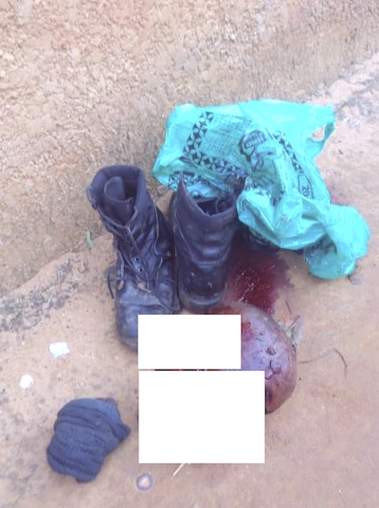

The decapitated victim was not identified

- A group of unidentified individuals carried out an attack on Buramata Hill, Gihanga commune, Bubanza province (western part of the country) on 11 February 2019 in the evening. Witnesses report that they wounded a man.

Sos-Torture/Burundi notes that Gihanga police intervened to stop the attack, but the agents did not arrest any members of this group.

- Unidentified individuals murdered a man whose decomposing body was discovered on Bambo Hill, Murwi commune, Cibitoke province (northwest of the country) on February 13, 2018. Witnesses report that the victim was tied up to a tree, proof of an execution.

Sos-Torture/Burundi notes that the victim was identified neither by the local inhabitants nor by the administrative authorities. However, these same authorities ordered the burial of this man, without allowing further investigations to identify him and the circumstances of his murder

- Violations of the right to liberty and physical security

- Rumonge prosecutor's office detained five (5) young men arrested on January 10, 2019 and never charged with an offence for prolonged and unlawful detention. They are Emmanuel Niyonganji, Mélance Irambona, Pascal Ahishakiye, Rénovat Ninteretse and Jean Bosco Niyomwungere. Since their arrest, Rumonge prosecutor's office has not provided any evidence or witnesses to support the charges against these young men. They are accused of having erased writings on a monument of the ruling party CNDD FDD in Burambi commune (see Sos-Torture Burundi report No. 162: http://sostortureburundi.org/wp-content/uploads/2019/01/SOS_Torture_Burundi_numero_162.docx).

Sos-Torture/Burundi notes that these five (5) young men were finally released on 13 February 2019 following the family pressure. They confirmed that the young men were victims of their political affiliation to MSD (Movement for Solidarity and Democracy).

- Agents of the national intelligence service arrested several influential members of the ruling party CNDD-FDD and its imbonerakure militiamen in Kirundo commune and province (northern part of the country) on 11 February 2019. Witnesses report that these arrests are the result of a search and seizure operation that resulted in the seizure of many firearms, including assault rifles. The targeted and arrested persons are: Abel Ahishakiye (representative of imbonerakure militiamen in Kirundo), Minani (vice-representative of the same militia), Nkurunziza and Macumi (former chief of Cewe zone of Kirundo commune). Witnesses also reported that at the latter's home (Macumi), SNR officers seized 4 Kalashnikov rifles.

Sos-Torture/Burundi notes that these seizures confirm allegations of the distribution of weapons to members of the imbonerakure militiamen in order to maintain terror and track down opponents. However, the persons arrested in possession of these weapons were released only after three (3) days of detention, the file was reportedly closed without further action by the police in complicity with the Public Prosecutor's Office in Kirundo. These releases thus indicate the authorities' complicity in the abuses committed by members of the imbonerakure militiamen in Kirundo.

- Members of imbonerakure militiamen attacked Arsène, a resident of Nyamugari quarter, Gitega commune and province (central part of the country) on February 11, 2019. Witnesses report that militiamen broke down the door of his home with clubs.

Sos-Torture/Burundi notes that the victim in defence injured one of the attackers named Ido Munezero. However, the police arrested the victim who was assaulted, leaving the militiamen who attacked him at his home free to do so

SOS-Torture/Burundi was initiated with the aim of informing national and international opinion about serious human rights violations under way in Burundi through monitoring reports on torture, arbitrary arrests, enforced disappearances, sexual violence and summary executions.
This initiative to inform about the country's realities followed the carnage of around 100 people killed on 11 and 12 December 2015 by the police and soldiers under the pretext of pursuing rebels who had just attacked military camps on the outskirts of the capital City.
The affected zones are said to be contesting President Nkurunziza's third term of office, namely Musaga, Mutakura, Cibitoke, Nyakabiga, Jabe, the last two being located in the centre of the Bujumbura City Hall.

