SOS-TORTURE/BURUNDI REPORT No. 179 ISSUED MAY 18, 2019
The report of SOS-Torture/Burundi covers the period from 11 to 18 May 2019 regarding cases of violations and abuses of human rights in Burundi.
At least three (3) persons were murdered during the period in different localities. Among the victims, two (2) persons were not identified after the discovery of their decomposing bodies. A former journalist with the independent radio Bonesha FM escaped an assassination attempt.
The report also mentions seven (7) arbitrary arrests of opposition members. All the victims are members of the CNL party. Another member of FRODEBU party was beaten by members of the militiamen Imbonerakure in Makamba during a political meeting of party members.

- Violations of the right to life and physical integrity

- Unidentified individuals attempted to assassinate Hassan Ruvakuki at his home in Kajaga neighborhood, Mutimbuzi commune, Bujumbura province (west of the city of Bujumbura) May 14, 2019 in the evening. Relatives report that these individuals attacked him with machetes, injuring his head and arm. Mr. Ruvakuki is a former journalist of Bonesha Fm radio before it was attacked, burned and closed by the Burundian authorities in 2015.

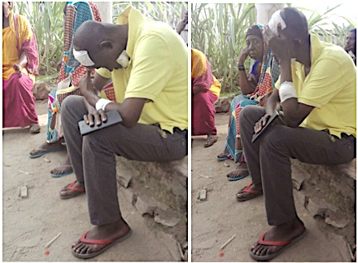
The journalist Hassan Ruvakuki after attack

- Unidentified individuals have murdered a woman whose body was found in the cross-road 8 on the Musenyi Hill, Mpanda commune, Bubanza province (west of the country) on May 15, 2019. Witnesses report that the body was in advanced decomposition.

SOS-Torture/Burundi noted that the victim was not identified by local residents or by the administration of Mpanda. The Police have also not yet identified the victim or the perpetrators of the murder.

- Unidentified individuals have murdered a man whose body was discovered on Mparambo II hill Rugombo commune, Cibitoke province (north-west) on May 16, 2019. Witnesses said the victim was tied up and in advanced state of decomposition.

SOS-Torture/Burundi notes that local administrative authorities ordered the burial of the body, without allowing investigations to identify the victim or his killers.

- Unidentified individuals murdered Celestin Nimbona whose body was found in a cemetery in Karonda, Rumonge Commune and Province (south-west of the country) on May 17, 2019. Witnesses said that the victim was injured throughout the body and his face disfigured.

SOS-Torture/Burundi notes that the police did not identify any suspects yet. The victim worked as a taxi driver motorcycle.

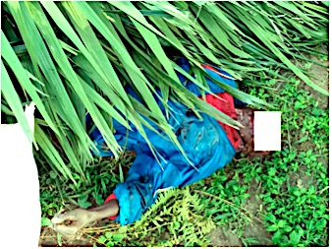
Mr. Nimbona murdered in Rumonge

- Violations of the right to liberty and physical security

- Police officers arrested Vénérand Masumbuko Patrick Leonidas Hakizimana and to Magara, common Bugarama Rumonge province (south-west) on May 11, 2019. Relatives report that three (3) men are activists of the party CNL opposition led by the member Agathon Rwasa. Mr Masumbuko is also representative of that party in the commune Bugarama. They are accused of failing to assist a person in danger. Relatives report that Imbonerakure militiamen stormed the home of Mr Masumbuko who had to defend the attack wounding one of the attackers.

SOS-Torture/Burundi rating arbitrary detention motivated by political affiliation of the victims. The three (3) men were transferred to Rumonge police Station on 13 May 2019. SOS-Torture/Burundi also notes a complicity of the police with members of the militiamen Imbonerakure none of the attackers were arrested, though Mr Masumbuko has identified Fabrice Ndayikengurukiye among them.

- Members of the militiamen Imbonerakure beaten Leonidas Nijimbere on Muyaga hill town Kayogoro, Makamba province (south) on May 12, 2019. Relatives report that the victim is the representative of the opposition party FRODEBU in Kayogoro commune. Mr. Nijimbere hosted a meeting of his party members at the time of the attack by members of the Imbonerakure militiamen of the ruling party came to arrest the meeting.

SOS-Torture/Burundi underscores the violence of the assault that occurred in front of numerous witnesses and the clear desire Imbonerakure militiamen not to tolerate any other political formation. None of the attackers were arrested despite a formal complaint by the victim. The militiamen identified during this assault are Gerard Minani Innocent Mpfanubusa Leonidas Toyi and Nduwamungu.

- Police agents stopped Emmanuel Manirakiza, Gilbert Niyonkuru, Epipode Nikobamye and Dieudonné Nikobamye in Gatete zone, Rumonge Commune and Province (south-west of the country) on May 15, 2019. Relatives report that four men are members of CNL opposition party accused of holding an illegal meeting.

SOS-Torture/Burundi note arbitrary arrests of opposition members. Among the arrested include local leaders of the party including Mr. Manirakiza, deputy provincial representative of the student members of CNL party in Rumonge. They are victims of their political affiliation, like other members of the party who suffered arrests cascading from the approval of CNL in February 2019.

- Untried prisoners for more than 3 years

SOS-Torture/Burundi learned about prolonged pretrial detention of prisoners arrested in 2015 for the murder of General Adolphe Nshimirimana, former head of the National Intelligence Service of Burundi. These detainees appeared on December 27, 2016 before the Ntahangwa Intermediate Court (north of the city of Bujumbura) itinerary in Gitega (center of the country) where they are incarcerated.

SOS-Torture/Burundi notes that since that date, the record of these detainees has never been sent before a judge to be ruled on the merits. This demonstrates the political nature of these detentions, alleged being all from the former Burundian Armed Forces (ex-FAB) of which many of their comrades were subjected to arbitrary detention, torture, enforced disappearances and summary executions since the beginning of the crisis.

Detainees victims of this prolonged detention without trial are military Patrick Nsengiyumva, Parfait Bigirumugisha, Jean Claude Muhimpundu, Ernest and Alexis Nyabenda Sebahene; and policemen Mathias Miburo and Philbert Niyonkuru all from the former Burundian Armed Forces commonly called ex FAB.

SOS-Torture/Burundi was initiated with the aim to inform the national and international opinion on serious violations of human rights ongoing in Burundi through monitoring reports including torture, arbitrary arrest, enforced disappearances, sexual violence and summary executions.
This initiative to inform about the realities of the country follows the slaughter of hundreds of people killed during the day of December 11, and that of December 12, 2015 by police and military under the pretext of pursuing rebels who came attacking military camps located on the outskirts of the capital.
The affected zones are said to be protesters third term of President Nkurunziza namely Musaga Mutakura, Cibitoke Nyakabiga, Jabe, the last two being located in the center of Bujumbura.

