SOS-TORTURE/BURUNDI REPORT No. 180 PUBLISHED ON MAY 25, 2019
This report of SOS-Torture/Burundi covers the period ranging between 18 and 25 May 2019 regarding cases of violations and abuses of human rights in Burundi.
At least three (3) persons were murdered during the period in different areas. Victims were members of the defense and security forces, two (2) police agents and one (1) Military. Another man escaped an assassination attempt in Cibitoke province.
The report also mentions thirteen (13) cases of arbitrary arrests. Victims were members of the opposition CNL party primarily, but also a trader and a teacher. These two (2) last people were arrested on the orders of the governor of Makamba. In addition, other opposition members militiamen were beaten up by Imbonerakure militiamen.

- Violations of the right to life and physical integrity

- A police agent shot Brigadier Nicolas Bwambarangwe in Kirundo commune and province (north) on May 19, 2019 in the evening. Relatives report that the author of the shooting, nicknamed Mwarabu was the transmission agent of the victim.

SOS-Torture/Burundi notes that Bwambarangwe police announced the arrest of the author alleged agent during his escape. This agent nicknamed Mwarabu was however shot down in turn by police agents who escorted him to the Kirundo prosecution service on 20 May 2019. The police said the victim had just "jump the vehicle" in an attempt 'evasion. SOS-Torture/Burundi nevertheless notes that Mwarabu was unarmed and did not constitute an immediate danger to his colleagues, to justify this extraordinary extrajudicial execution.

- Unidentified individuals attempted to assassinate Bihehero Fabien (70 years) on Buzirasazi hill, Murwi commune, Cibitoke province (north-west) on May 20, 2019 in the evening. Relatives reported that gunmen with spears and machetes entered her home and stabbed the victim.

SOS-Torture/Burundi notes that Mr. Bihehero in dying state was evacuated to a hospital for care. Murwi police did not arrest any suspect to date. Relatives of Mr. Bihehero thought that criminals were targetting his son Patrice Nyabenda, representative of the UPRONA (presidential party) in this Commune.

- A police agent shot Alexis Ndihokubwayo on RN9 national road between Rugazi and Mutimbuzi commune of Bubanza and Bujumbura province on May 22, 2019 in the evening. The victim is a Burundian military. Witnesses report that he was in civilian clothes at the time of being shot by the police agent. The author of the murder is part of the custody of the public prosecutor in Bubanza that moved away. The victim cut priorityto the vehicle of the prosecutor before being shot.

SOS-Torture/Burundi noted an excessive use of violence for a minor traffic violation. The author of the fatal shooting was not apprehended.
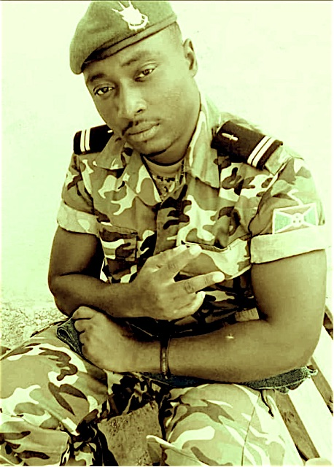
Alexis Ndihokubwayo, military shot dead by a police agent

- Violations of the right to liberty and physical security

- Members of the militiamen Imbonerakure beaten Antoine Rwasa, Jean Marie Bizimana, Christophe Ndikumagenge and Minani (nicknamed Kwanda) on Murungurira hill Ntega Commune, Kirundo province (north of the country) on May 18, 2019. Relatives report that these men are all members of the opposition party CNL (National Congress for Freedom) led by MP Agathon Rwasa. Witnesses report that Imbonerakure militiamen flooded the respective homes of the members of the opposition as well as those of two of their comrades who fled when they arrived. The persons referred tried to defend but were mastered and beaten by a dozen of Imbonerakure militiamen.

SOS-Torture/Burundi notes the violence of the attack by members of the militiamen of the ruling party against the opposition members. Inflicted blows have led to the hospitalization of two (2) among the victims. Witnesses also reported the presence of two (2) police agent who accompanied and helped the militiamen during the violence. This is a blatant complicity of the officials in abuses by the militiamen of the ruling party. SOS-Torture/Burundi notes that none of the attackers were prosecuted.

- Police agents arested Audace Barutwanayo on Nyamutobo hill, Gishubi commune, Gitega province (center of the country) on May 19, 2019. He is a member of the opposition party CNL accused of burning the coumpound of 'a property.

SOS-Torture/Burundi noted that relatives of Mr Barutwanayo worry and denounce a pretext to arrest because of his membership in the opposition.

- Police agent also arrested Aloys Niyonkuru on Ngaruzwa hill, Ryansoro Commune, Gitega province (center of the country) on May 19, 2019. Relatives report that Mr. Niyonkuru is also a member of the opposition party CNL. He was arrested at the end of a mass celebration.

SOS-Torture/Burundi noted that the concerned was not notified of the reasons for his arrest. It is arbitrary arrest conducted without warrant and raises fears of political motives.

- Police agents arrested Marc Nsavyimana, Dismas Hakizimana, Gabriel Marimbu, Etienne and Jean Harushimana Jean de Dieu Miburo in Gihanga commune, Bubanza province (west of the country) on May 21, 2019. All are members of the opposition party CNL accused of holding an unauthorized meeting.

SOS-Torture/Burundi notes again arbitrary arrests of opposition members.

- Police agents arrested Gerard Habarugira on Rubimba hill, zone and Kibago commune, Makamba province (south of the country) on May 21, 2019. Witnesses report that the order of the arrest comes from the governor of Makamba Gad Niyukuri who was on Rubimba hill for a security meeting. Relatives report that Mr. Habarugira suffered filing a complaint against the zone leader Kibago Phénias Kabura after the latter had beaten and robbed.

SOS-Torture/Burundi rating arbitrary arrest and complicity of the governor of Makamba in abuses by Kibago zone chief, both members of the ruling CNDD-FDD. SOS-Torture/Burundi also notes the total inertia of Makamba prosecutor who did not respond to the complaint filed by Mr. Habarugira.

- Police agents arrested Gilbert Nahimana in Nyanza Lac commune, Makamba province (south of the country) on May 21, 2019. He is a teacher of the municipal school Karobane (Nyanza Lac commune). Relatives reported that the governor of Makamba Gad Niyukuri gave the order of arrest. The school director accused Mr. Nahimana refusing to teach physics. Relatives report that concerned explained not have the skills to do it, not having seen this course during his academic career.

SOS-Torture/Burundi rating arbitrary and wrongful arrest. The provincial governor abuses his power to interfere in a matter that has nothing criminal.

- The head of the National Intelligence Service of the Bururi Province arrested Emmanuel Nduwimana (15 years), Bruce Dushime (16 years), Tecie Tychique Mutumwa (16 years) and Faustin Igiraneza (16 years) in the locality of Kiremba municipal school, Bururi Province (south of the country) on May 23, 2019. These children are accused of "scribbling" the picture of the Burundian President Pierre Nkurunziza in textbooks.

SOS-Torture/Burundi notes arbitrary arrests for a situation where the school rules would have been enough to punish wrongdoers. The governor of Bururi province intervened to release them due to "lack of evidence"; the release was effective on May 24, 2019. This is not the first time that the security services arrest on children for the same reasons.

SOS-Torture/Burundi was initiated with the aim to inform national and international opinion on serious violations of human rights ongoing in Burundi through monitoring reports on torture, arbitrary arrest, enforced disappearances, sexual violence and summary executions.
This initiative to inform about the realities of the country follows the slaughter of hundreds of people killed during the day of December 11 and 12, 2015 by policemen and soldiers under the pretext of pursuing rebels who came to attack military camps located on the outskirts of the capital city.
The affected zones are said to be protesters of President Nkurunziza’s third term namely Musaga Mutakura, Cibitoke Nyakabiga, Jabe, the last two being located in the center of Bujumbura.

